**Geography Review paper 4**

**Email; [nyagahimal@gmail.com](mailto:nyagahimal@gmail.com)**

**The relationship between Earth Structure and Continental drifting.**

Our habitat Earth is comprised of the land that is mainly soil and minerals, massive water bodies and inland water bodies and atmosphere. The atmosphere begins from ground level or sea level up to the ozone layer past the clouds up to the sky which unfortunately is the limit with its luminaries or stars.

These elements land,air and water are also necessary to identify the undeniable structure of our Earth. according the layout of these main elements on Earth, one can make a definitive description or conclusion of what is the final structure that composes together these elements of Earth.

Land is the solid element or part of Earth that is comprised of mainly the continents and islands that sit on the tectonic plates and water of liquid nature includes oceans, lakes, rivers and other water bodies which are very important in knowing the structure of Earth.

Continents as we know are large land masses sitting on tectonic plates and surrounded by water and islands are small land masses surrounded by water. Further more we have ice blocks and ice highlands or glaciers also in areas of extreme cold temperatures like Arctic and Antarctica regions

These continents and water bodies were all subject to forces that drifted the continents apart and distributed them where they are presently,This well stated and elaborated by the well known theory called continental drifting that is also well supported with physical evidences.

**Continental drifting theory**

The theory states that current evidence from all continents concludes that millions of years ago, the continents were one big super continent called Pangea sorrounded by a water body Panthalesa.The first tectonic movements split them into 2 continents Laurasia and gondwanaland, during seafloor spreading era oceans drifted apart along ocean beds and continents along tectonic plates.

**Sketch map Illustrating Continental drifting of Earth.**



Fig.1: <http://earthguide.ucsd.edu/eoc/teachers/t_tectonics/p_pangaea2.html>

**Relation ship between continental drifting and Earth structure.**

The first issue we examine is the original nature of Earth before continental drifting, having noted that all the continents were one big super continent called pangea surrounded by one massive water body called panthalassa, we closely examine their relation to outline the whole structure.

However the concept of Earth being a spinning geoid in space is incompatible or does not match the mere definition of continental drifting quoting that “the Earth was one big super continent surrounded by water” this can be related to an island surrounded by water or you can practically indicate it by getting a mound of solid mud or concrete and place it in the middle of a basin and the pour water to surround the mound.

The indication of the first super continent pangea surrounded by water on a spinning geoid is impossible and impossible is emphasized because if it were true or possible whoever could, would have done it .However The indication of continental drifting and sea floor spreading is much simply possible on a level plane with a grand hollow basin to contain the oceans and the Earth in the center of this ocean.

**Illustration of continental drifting on stationary horizontal hollow surface**

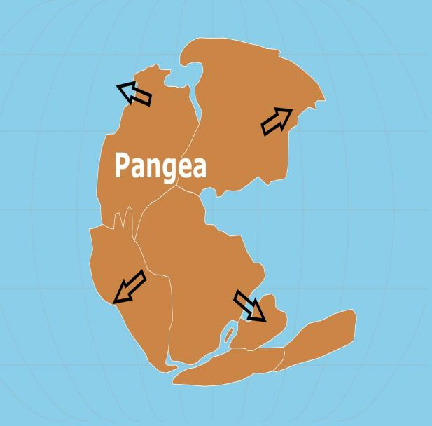****

As stated the water surrounded the land, in a similar way water surrounds an island and this can only occur in a basin or hollow structure for water to surround land. Due to continuos activity of heating by the sun and other factors, the continents drifted along ocean currents and weak tectonic lines to give the current day continents as indicated above.

During continental drifting, tectonic plates were moving apart in different directions but not according to the direction of the rotating force(clockwise) which is incompatible with a spinning geoid, because as earth rotates and tectonic plates being weak the force spinning the earth acts first and foremost on this weak tectonic lines and collides or separates in patterns that would leave fragments and collisions that indicate one direction of rotating.

Furthermore, If Earth was a spinning geoid in space we first question in which hemisphere was the water and land before drifting occurred, furthermore we would also question how and where were these elements (Water and land) appeared from before questioning how they were in equilibrium or distributed on a sphere without a hollow containment for the water to not pour from either extremes of the south pole or north pole depending on the orientation or projection of this sphere insinuated before we consider whether it was spinning then or not.

As sea floor spreading occurred,it evident even today from oceanography that the ocean bed or sea bed spread out and is basin shaped with different depths at different parts all by continental shelfs and sea level being horizontal from one continental shelf to the other.

Map shows the pacific ocean floor and continental shelf of continents around it forming boundary of the ocean basin or ocean floor.

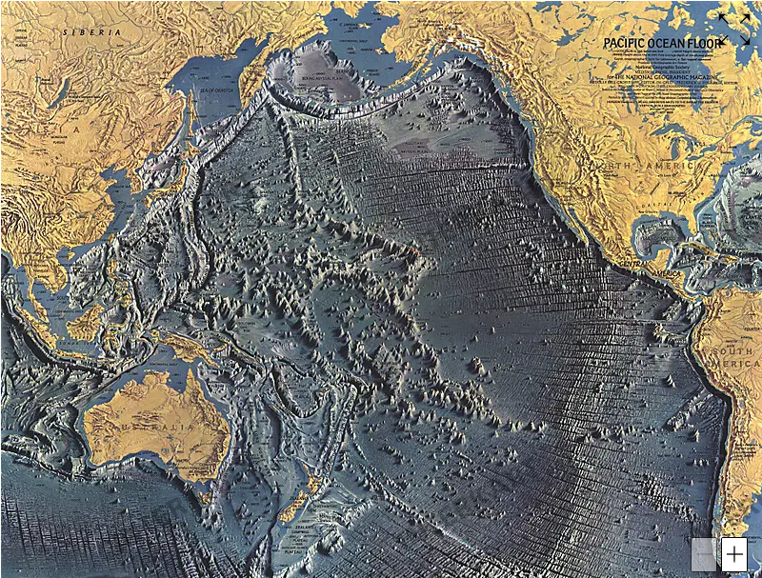

The pacific ocean covers almost half of the globe or sphere modal and it appears to bend in a convex manner all over especially at the equator which is a totally false concept or illustration as see from the above illustration the pacific ocean and all other ocean floors do not bend to form a sphere but rather to form a hollow basin like shape to contain the waters.

By examining the pacific ocean floor we see that a detailed picture indicates the entirety of the pacific ocean basin from S.America to N. America onwards to Russia, Siberia and East Asia coast connecting with Australia and Antarctic to contain the pacific ocean in this big basin surrounded by mentioned continents .

In order for water and land to coexist on a sphere whereby water is 71% there would need a hollow structure to contain this water and if more than 70% of a sphere is hollow, then it is no longer a sphere but a hollow irregular structure.

South America East coast and Africa west coast appear to fit together indicating they drifted apart South America going West and Africa going East, however also Madagascar also indicates that it was part of Africa although it drifted Eastwards as well as Australia, indicating land drifting in different directions but it is stated Earth spins in one clockwise direction from West to East.” this should have drifted the continents to one direction of the spinning geoid and also changing the structure of the sphere since there evident basins in between continents

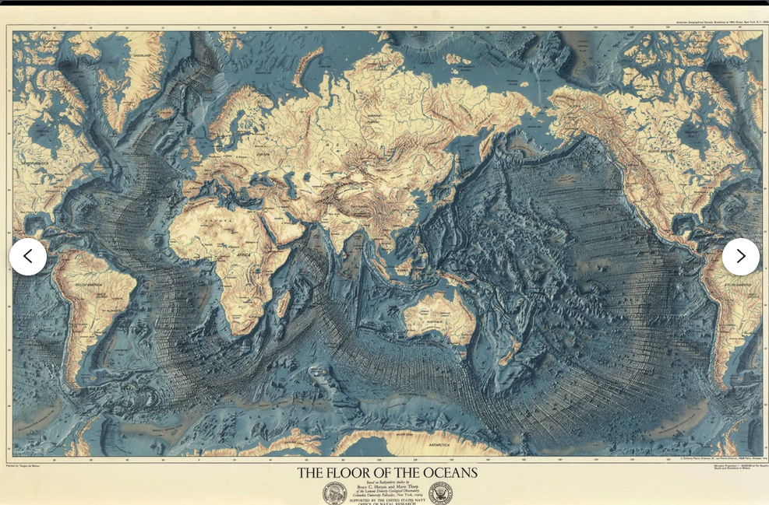

According to current structure of the continents and ocean floor, we see large depressions or hollowlike basin structures between continents that have coastline that could fit perfectly into each other which supports the theory of continental drifting and sea floor spreading. With this evidence we note the evidential floor like spreading of the ocean bed and difference depth of the ocean floor and in elevation of continents as compared to the sea level.

**Using sea level to confirm structure of the Earth**

“Sea level is the base level for measuring elevation and depth on Earth. Because the ocean is one continuous body of water, its surface tends to seek the same level throughout the world.” <https://education.nationalgeographic.org/resource/sea-level/>

Having noted the definition of the sea level, we know the ocean is continuous body of water between continents and “its surface tends to seek the same level throughout the world”. we relate the sea level with the continents after continental drifting to note the dimensions of Earth.

The sea level between continents being the same leaves no possibility of a spherical structure as indicated below

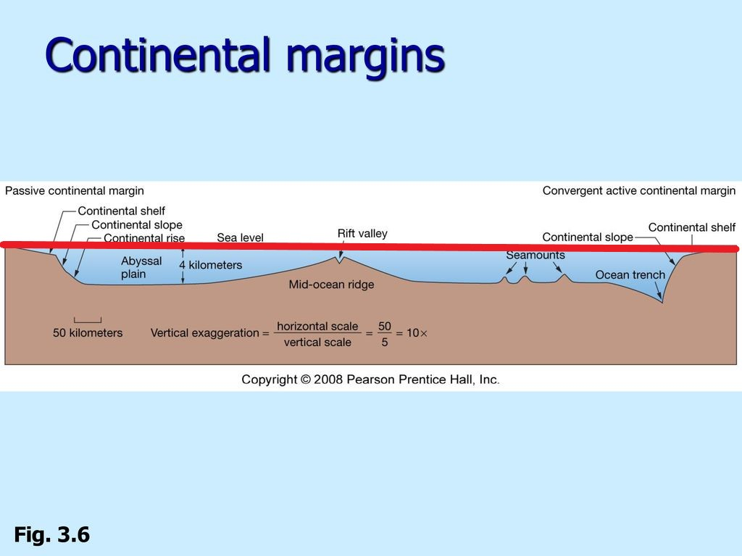

**The red line in the diagrams indicates the sea level from continent to continent**

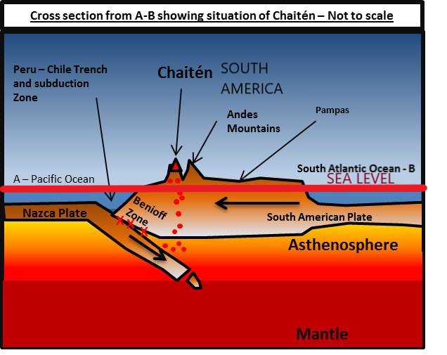

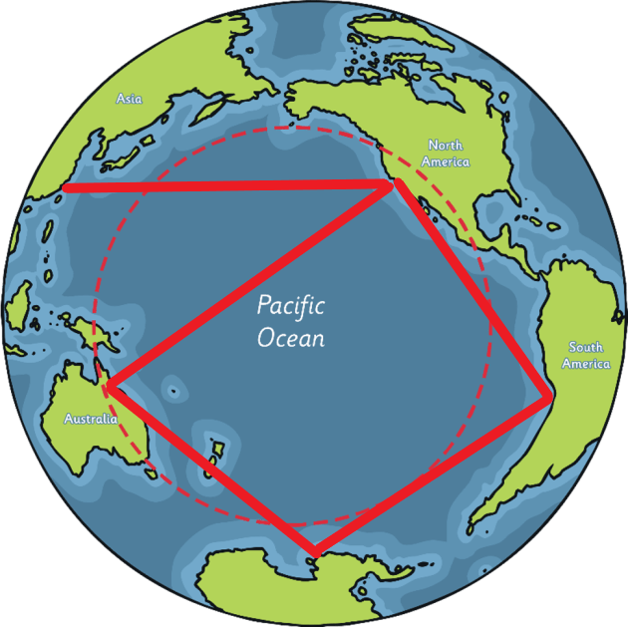

The above illustration indicates the sea level of the pacific ocean from coast to coast using the red line to indicate the horizontal sea level as viewed from above.

Noting that from one coast to another coast is horizontal sea level, the possibility of earth being a sphere continues to diminish leaving little but no chance.

**Sketch map showing the Ocean floor of Indian ocean and horizontal sea level in red line.**

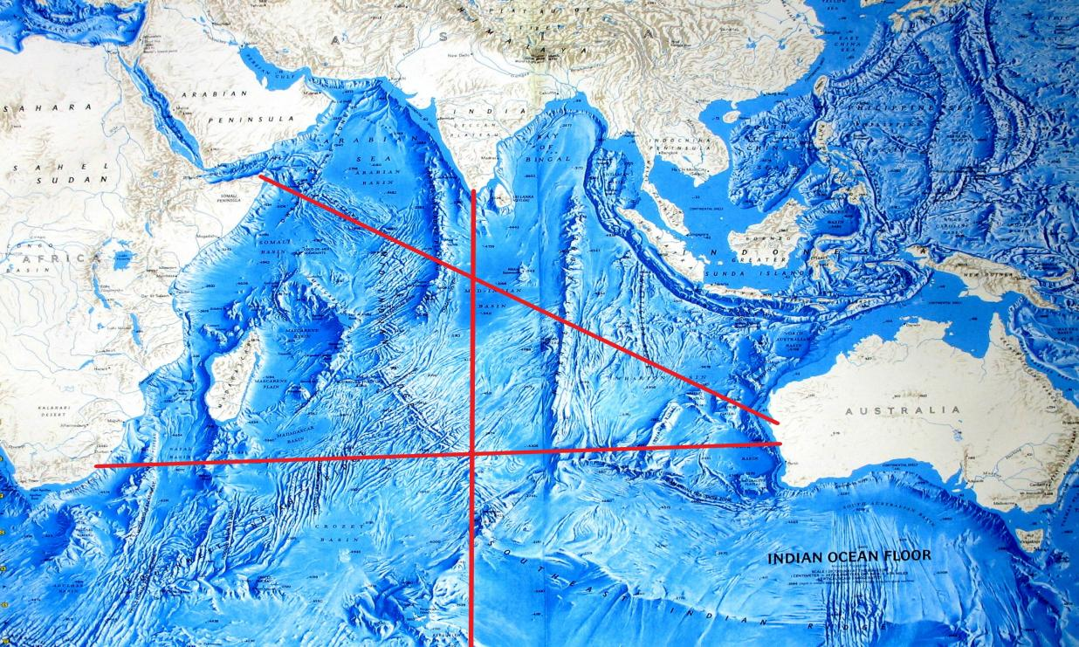

After indicating the horizontal sea level from coast to coast of every continent, we firmly conclude that from coast to coast of each continent is a level plane which varies in altitude or depth of the sea at specific areas and not like a sphere in all directions.

To add on, the rotating motion causes wind to blow in the opposite direction as seen from the relation of wind and Earth structure which would catalyse eroding and mass weathering that is evident of the rotating forces direction. However this is not evident as weathering is seen to occur in different directions due to different reasons unlike if Earth was a spinning geoid.

Furthermore this rotating force would have also caused the water to overflow on east coasts of continents or islands continuosly daily in relation to the rotation of the Earth, but with oceans and other water bodies intact this goes on to disprove the possibility of Earth being either a sphere or spinning in space.

If the earth was a globe and spinning in space during this time, water would have flowed down the southern current to the south pole if the sea floor was spreading on a geoid spinning vertically upright as we see it projected.

As noted that the sea level does not bend,this disproves the possibility of a globe because at the end of the day water settles in a container. this containment is evident in stationary structure.

**Image of Earth as claimed captured by NASA**



Fig.2 Blue marble NASA 2012.

According to the Image presented by NASA, We are left to ponder how water was contained before and after continental drifting on the globe structure but this is not questionable as it is clearly understandable on the stationary structure a shown below.



The continents as shown in fig.1 are; Africa, India, Asia, Europe, Australia,North America and South America plus Antartica is the name given to the ice highlands that surround the oceans and Earth like a ring and appear as you sail south wards from any given location past 60 latitude south. The theory of tectonic plates and continental drifting shows the earth split up in different directions and water relocating to where the land split apart which is impossible on an oblete geoid sphere spinning in space and vertically tilted as shown in fig.2 below

From the illustration above the containment of water by Antartica ring all round with the sea level putting all continents at an average level is evident that Earth is neither a sphere nor spinning in space hence concluding the earth is stationary land and water bodies in a grand water basin( That holds/ keeps the waters within our territory.)